|  |  |
| --- | --- |
| 4. | Determine the command bytes for the following operations-   1. Set the value at PORT C to 2H 2. GROUP A operating on MODE 1 as I/P port, GROUP B operating on MODE 0 as O/P port |

Answer to question no 4(a)

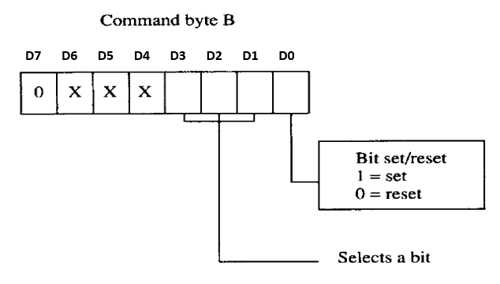

For bit set D0=1 and D7=0. The truth table for selecting the value of the bit is as follows-

|  |  |  |  |
| --- | --- | --- | --- |
| D3 | D2 | D1 | BIT |
| 0 | 0 | 0 | 0 |
| 0 | 0 | 1 | 1 |
| 0 | 1 | 0 | 2 |
| 0 | 1 | 1 | 3 |
| 1 | 0 | 0 | 4 |
| 1 | 0 | 1 | 5 |
| 1 | 1 | 0 | 6 |
| 1 | 1 | 1 | 7 |

From the truth table to set the value to 2H- D1=0, D2=1, D3=0. The other bits are don’t care

Therefore, the command bye is-

|  |  |  |  |  |  |  |  |
| --- | --- | --- | --- | --- | --- | --- | --- |
| **D7** | **D6** | **D5** | **D4** | **D3** | **D2** | **D1** | **D0** |
| 0 | x | x | x | 0 | 1 | 0 | 1 |

Answer to question no 4(a)

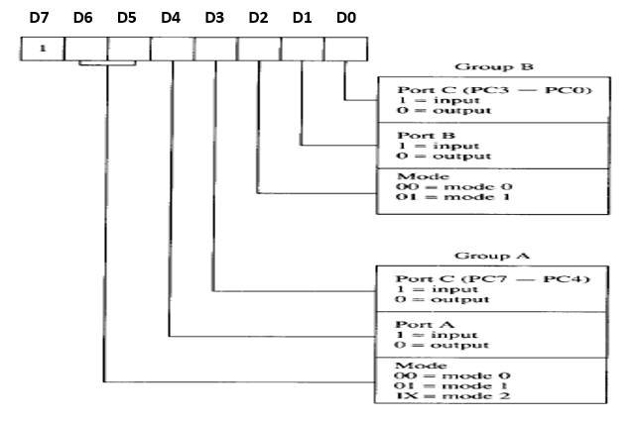

For input/output mode D7=1

GROUP A operating on MODE 1 as Input port. Therefore,

D3=1, D4=1

D6=0,D5=1

GROUP B operating on MODE 0 as Output port. Therefore,

D0=0, D1=0, D2=0

Therefore, the command bye is-

|  |  |  |  |  |  |  |  |
| --- | --- | --- | --- | --- | --- | --- | --- |
| **D7** | **D6** | **D5** | **D4** | **D3** | **D2** | **D1** | **D0** |
| 1 | 0 | 1 | 1 | 1 | 0 | 0 | 0 |